SUPPLEMENTARY DATA
SUPPLEMENTARY TEXT
Normal mode analysis using elastic network models
In GNM (1,2) and ANM (3), the structure is regarded as a collection of nodes representing the Cα atoms, with springs connecting Cα-atoms that are located within a specific distance from each other. The particular topology is the sole determinant factor of the collective modes of motion. As an isotropic and one-dimensional model, GNM is able to predict the magnitudes (sizes) of fluctuations, while ANM also characterizes the directions of these fluctuations. The prediction of mean-square fluctuations of the residues is considered more robust in GNM compared to ANM (4). GNM was therefore used in this study to infer the relative magnitudes of the residues’ fluctuations, and consequently to identify the hinge (immobile) and highly mobile regions. This elastic model was also employed to attain the cooperative motion of the residues in each mode. ANM, on the other hand, was used to predict the directions of motion, generating the conformation that describes each observed motion. The motions were analyzed in accordance with the mean-square fluctuations (MSFs) and correlated dynamics derived from corresponding GNM modes. To obtain an accurate match between the examined GNM and ANM modes, we correlated their MSFs (Fig. S5).
The calculations were conducted using the commonly-used distance cutoffs between the Cα atoms of the amino acids, i.e., 10 Å for GNM and 15 Å for ANM. However, to examine the robustness of the analyses, we also carried out calculations using distance cutoffs of 7 Å and 13 Å for GNM, and 18 Å for ANM. Reassuringly, the GNM-derived MSFs and cross-correlations, as well as ANM-induced directions of motion, remained essentially the same when these alternative parameters were used (data not shown).
The first two GNM modes showed the greatest contribution to the protein’s motion, with each composing more than 4% of the overall motion (Fig. S4). The third GNM mode also displayed a relatively significant contribution of ~2.5%, whereas the following modes contributed 2% and below. In this study, we chose to focus on the first two GNM modes, to which we also successfully matched ANM modes and thus could explain the direction of motion in 3D space. We failed to unambiguously associate an ANM mode to the third GNM mode, and we did not analyze it.

The NhaA structure
NhaA is a dimer in the membrane (5-7), but we focused on the monomeric structure owing to three main considerations: (i) Studies have shown that the isolated monomer is functional, while dimerization contributes to stability and function only under extreme conditions (6,7). (ii) The available dimeric conformation is a model, derived from intermediate-resolution structural data (8), and therefore might be less accurate than the structure of the monomer. (iii) GNM and ANM calculations revealed the same motions for the monomer and dimer (data not shown). For instance, comparison of residues’ average MSFs calculated for the dimeric model-structure (PDB id 3FI1) and for the monomeric structure (PDB id 1ZCD) shows that fluctuations derived from the monomer and from the dimer are of similar shape and have similar hinge (immobile) regions. Furthermore, fluctuations from both structures are similar to experimental B-factors available for the monomeric crystal structure (Fig. S10). However, the motion of the beta sheet between TM1 and TM2, mediating the dimeric interface, are overestimated in the calculations performed for the monomer compared to the dimer.

Evolutionary conservation analysis
The evolutionary conservation analysis of NhaA was based on an extended collection of sequence homologues. To obtain this collection, we initiated a BLAST search (9) of the sequence of NhaA against the UniRef90 database (10), and collected only hits with E-values below 0.001, while removing proteins whose sequence identity with the query protein was lower than 20%. This yielded a collection of 480 homologues, which were then aligned using MAFFT (11). The resultant multiple sequence alignment was used in the ConSurf webserver (http://consurf.tau.ac.il/, (12)) to calculate evolutionary conservation scores, which were mapped onto both the crystal structure and the periplasm-facing model (Figs. S11A and S11B).

Regions of lower confidence in the periplasmic-facing model
By its nature, the modeling procedure employed for constructing the periplasm-facing conformation models some regions better than others. As the model is based on pseudo-symmetry between the TM helices, we could not attribute equivalent regions to the more flexible loops, including the loop between TMs I and II, which contains a small helix followed by two β-strands. These regions were modeled without a template using Modeller, and we cannot vouch for the accuracy of the obtained conformations. While the TM VI-VII segment retained its structural conformation from the crystal structure, we could not unambiguously determine its position relative to the rest of the structure, nor the helix-helix interaction between TMs VI-VII and the surrounding helices. Indeed, this segment was poorly packed against adjacent segments in the model-structure. Nevertheless, since this segment is also located in a peripheral region in the crystal structure, far away from putative functional regions such as the cytoplasmic and periplasmic funnels and the TM IV-XI assembly, we argue that these helices do not directly contribute to the transport mechanism in either state. Consequently, their precise positioning is of less importance. In the dimeric model, TMs VI-VII are in the interface between monomers (8), and we speculate that any motion and conformational changes in this region are restricted by these interactions. Another uncertain region is TM XIp, which is buried in the protein core and is uniformly conserved. Thus, we could not assess its rotational angle on the basis of considerations of evolutionary conservation and/or hydrophobicity. To maintain consistency with the crystal structure, we retained a similar rotation angle of TM XIp in the model-structure, but we cannot preclude the possibility that this structural element undergoes rotational motion upon the transition between the cytoplasmic and the periplasm-facing states.

REFERENCES
1. Bahar, I., Kaplan, M., and Jernigan, R. L. (1997) Proteins 29, 292-308.
2. Haliloglu, T., Bahar, I., and Erman, B. (1997) Physical Review Letters 79, 3090-3093
3. Atilgan, A. R., Durell, S. R., Jernigan, R. L., Demirel, M. C., Keskin, O., and Bahar, I. (2001) Biophys J 80, 505-515
4. Rader, A. J., Chennubhotla, C., Yang, L.-W., Bahar, I., and Cui, Q. (2006) The Gaussian Network Model: theory and applications. in Normal Mode Analysis - theory and applications to biological and chemical systems, Chapman & Hall/CRC. pp 41-63
5. Gerchman, Y., Rimon, A., Venturi, M., and Padan, E. (2001) Biochemistry 40, 3403-3412
6. Rimon, A., Tzubery, T., and Padan, E. (2007) J Biol Chem 282, 26810-26821
7. Herz, K., Rimon, A., Jeschke, G., and Padan, E. (2009) J Biol Chem 284, 6337-6347
8. Appel, M., Hizlan, D., Vinothkumar, K. R., Ziegler, C., and Kuhlbrandt, W. (2009) J Mol Biol 388, 659-672
9. Altschul, S. F., Madden, T. L., Schaffer, A. A., Zhang, J., Zhang, Z., Miller, W., and Lipman, D. J. (1997) Nucleic Acids Res 25, 3389-3402
10. Suzek, B. E., Huang, H., McGarvey, P., Mazumder, R., and Wu, C. H. (2007) Bioinformatics 23, 1282-1288
11. Katoh, K., Kuma, K., Toh, H., and Miyata, T. (2005) Nucleic Acids Res 33, 511-518
12. Ashkenazy, H., Erez, E., Martz, E., Pupko, T., and Ben-Tal, N. (2010) Nucleic Acids Res 38, W529-533
13. Herz, K., Rimon, A., Olkhova, E., Kozachkov, L., and Padan, E. (2009) J Biol Chem
14. Diab, M., Rimon, A., Tzubery, T., and Padan, E. (2011) J Mol Biol 413, 604-614
15. Tzubery, T., Rimon, A., and Padan, E. (2008) J Biol Chem 283, 15975-15987
16. Tzubery, T., Rimon, A., and Padan, E. (2004) J Biol Chem 279, 3265-3272
17. Kessel, A., and Ben-Tal, N. (2002) Peptide-Lipid Interactions 52, 205-253
18. Noumi, T., Inoue, H., Sakurai, T., Tsuchiya, T., and Kanazawa, H. (1997) J Biochem 121, 661-670
19. Arkin, I. T., Xu, H., Jensen, M. O., Arbely, E., Bennett, E. R., Bowers, K. J., Chow, E., Dror, R. O., Eastwood, M. P., Flitman-Tene, R., Gregersen, B. A., Klepeis, J. L., Kolossvary, I., Shan, Y., and Shaw, D. E. (2007) Science 317, 799-803
20. Galili, L., Herz, K., Dym, O., and Padan, E. (2004) J Biol Chem 279, 23104-23113
21. Galili, L., Rothman, A., Kozachkov, L., Rimon, A., and Padan, E. (2002) Biochemistry 41, 609-617
22. Kozachkov, L., Herz, K., and Padan, E. (2007) Biochemistry 46, 2419-2430
23. Olkhova, E., Kozachkov, L., Padan, E., and Michel, H. (2009) Proteins 76, 548-559
24. Inoue, H., Noumi, T., Tsuchiya, T., and Kanazawa, H. (1995) FEBS Lett 363, 264-268
25. Rimon, A., Gerchman, Y., Olami, Y., Schuldiner, S., and Padan, E. (1995) J Biol Chem 270, 26813-26817
26. Gerchman, Y., Olami, Y., Rimon, A., Taglicht, D., Schuldiner, S., and Padan, E. (1993) Proc Natl Acad Sci U S A 90, 1212-1216
27. Olami, Y., Rimon, A., Gerchman, Y., Rothman, A., and Padan, E. (1997) J Biol Chem 272, 1761-1768
28. Venturi, M., Rimon, A., Gerchman, Y., Hunte, C., Padan, E., and Michel, H. (2000) J Biol Chem 275, 4734-4742
29. Rimon, A., Gerchman, Y., Kariv, Z., and Padan, E. (1998) J Biol Chem 273, 26470-26476

SUPPELMENTARY FIGURES
Figure S1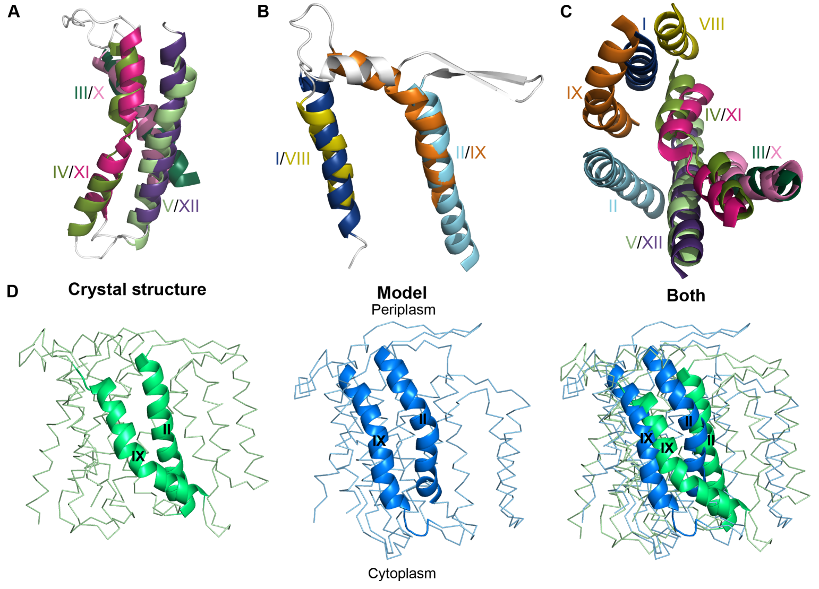
Figure S1. Structural similarity and conformational changes in TMs I-II and VIII-IX, as well as TMs III-V and X-XII. In panels A-C, the TM segments, shown in cartoon representation, are colored as in Fig. 1A, and the extra-membrane regions are white. A. Structural similarity of TMs III-V and TMs X-XII (labeled). The segments are viewed from the side and were aligned using SKA. It is evident that the two segments share significant structural similarity. B. Structural alignment of TMs I-II and TMs VIII-IX, also performed with SKA. This alignment places the membrane-embedded N-terminus of TM IX onto the extra-membrane helix between TM I-II, which is counterintuitive. The C-terminal end of TM II, on the other hand, is not matched to a corresponding helical segment in TM IX. C. Top view of segments 1-4 (Fig. 1A). The helical segments are labeled, and extra-membrane regions are removed for clarity. The segments are superimposed using the SKA fit of TMs III-V on TMs X-XII. It is evident that this fit does not superimpose TMs I-II and VIII-IX, but imposes a relative rotation of the two segments around a putative axis in the center of the structure. D. Conformational switch between TMs II and IX, leading to the cytoplasm-facing conformation. A side view of the crystal structure and periplasm-facing model, shown in ribbon representation, with TMs II and IX in cartoon representation and labeled. The crystal-structure (blue), model (green) and a superposition of the two are displayed from left to right. By construction, in the model, TMs II and IX adopt similar conformations to those of TMs IX and II in the crystal, respectively.

Figure S2

Figure S2. The sequence alignment employed for constructing the periplasm-facing model. The numbers of the 12 TM helices, extracted from the crystal structure, are marked on both the model and template sequences. The boundaries of the TM helices are shown using colored boxes, with a different color assigned to each helix. The sequence of the template is not ordered as in the actual NhaA sequence, but is a rearrangement of its various regions, which simplifies the structural modeling according to pseudo-symmetry defined in Figs. 1A and 1B.

Figure S3
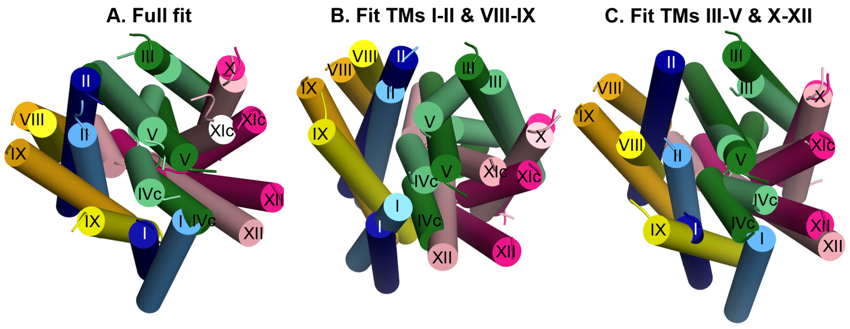
Figure S3. Comparison of the crystal structure and model using different selections for the superposition. In all panels, the crystal structure and periplasm-facing model are shown as in Fig. 2 and viewed from the cytoplasm. The helical segments are labeled. A. Structural fit using all helical segments, showing the two domains’ movements relative to each other. B. Superimposition based on the structural fit of TMs I, II, VIII and IX (i.e., segment 1 in blue and segment 3 in orange/yellow). It is apparent that TMs IX, V, X and XI of the model have undergone a rotation within the plane of the membrane relative to the fitted helices, around an axis perpendicular to the membrane that runs approximately through TMs III and X, compared to the corresponding helices of the crystal structure. C. Superimposition based on the structural fit of TMs III-V and X-XII (i.e. segment 2 in greens and segment 4 in pinks), revealing the reciprocal relative rotation of segments 1 and 3 (TMs I, II, VIII and IX). Since the domain containing segments 2 and 4 is circular (viewed from above), whereas the domain containing segments 1 and 3 is curved around it, the structure and movement can be compared to that of a two-dimensional ball-and-socket joint.

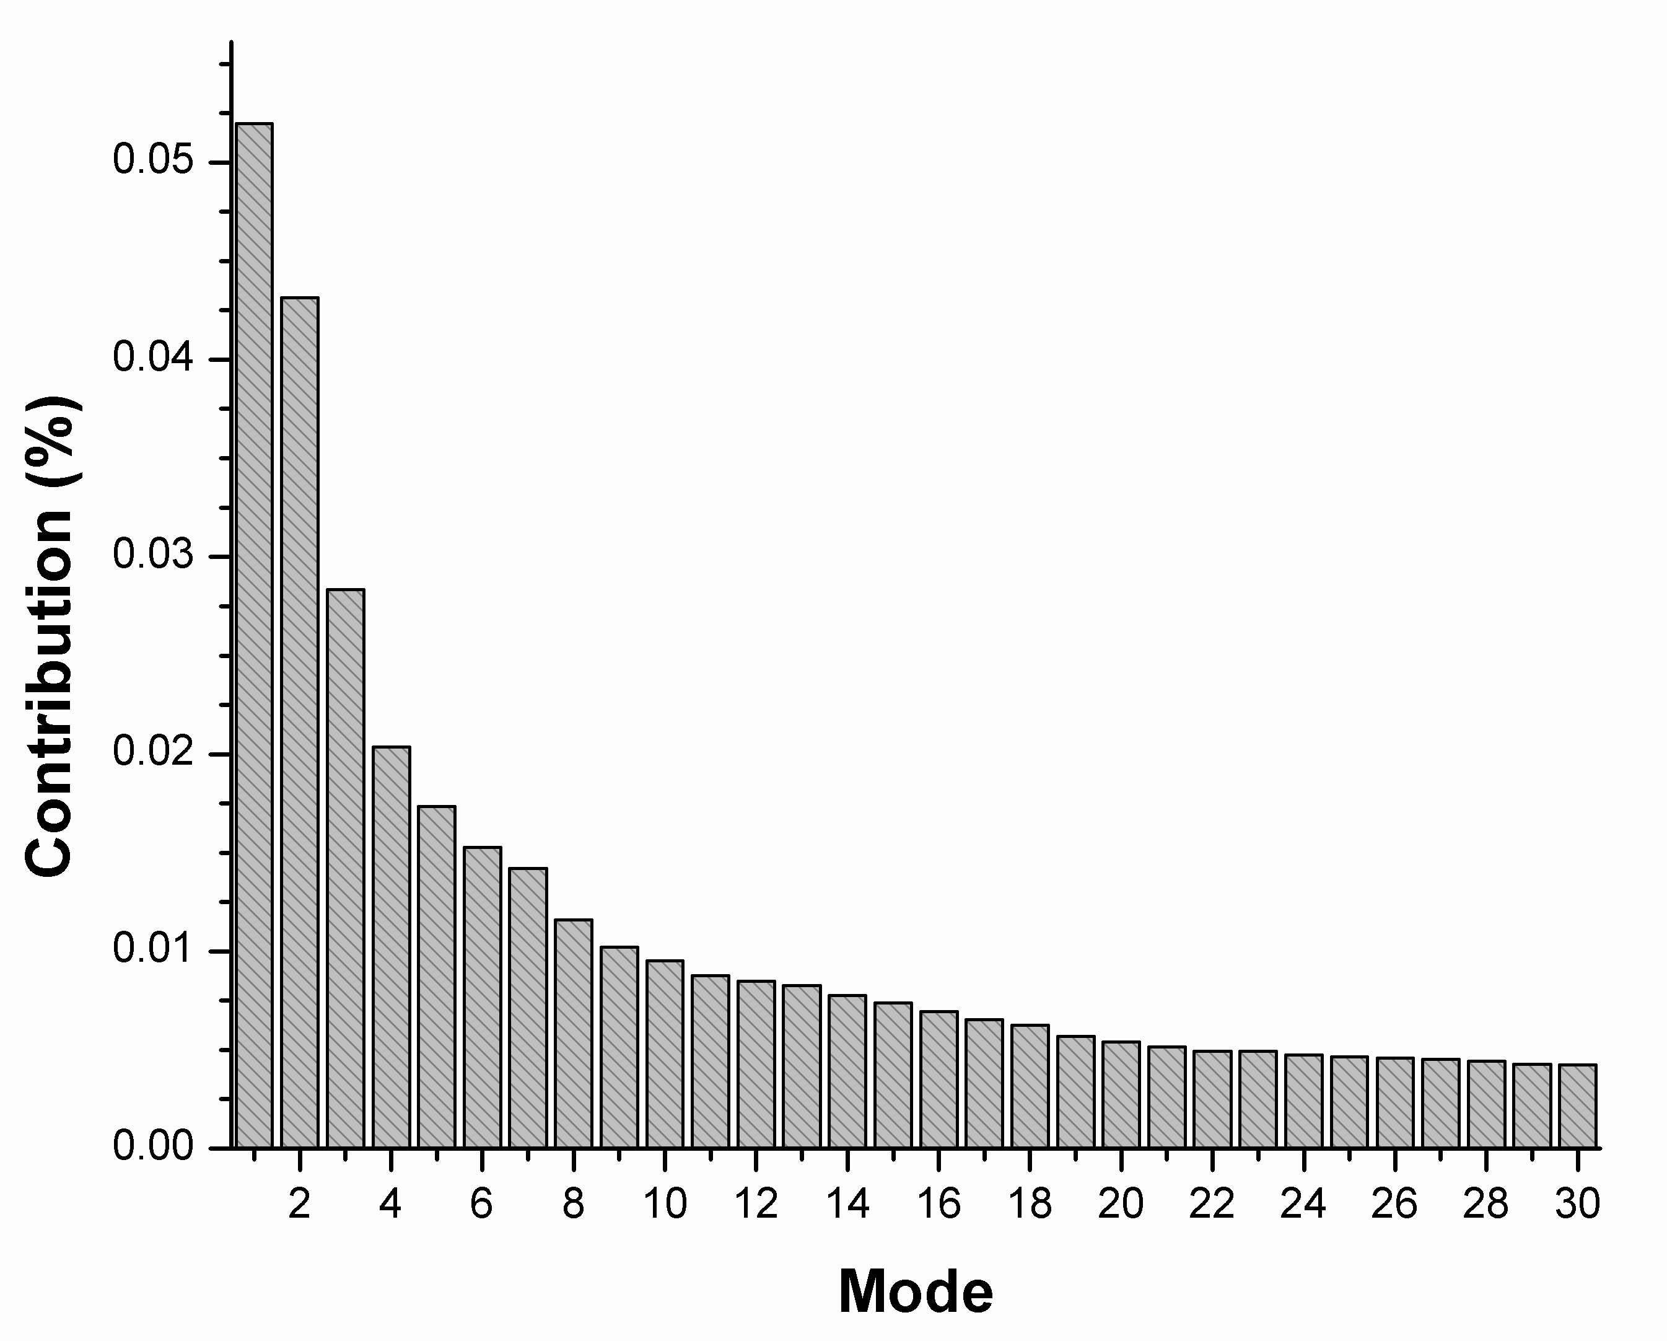
Figure S4

Figure S4. Contribution of GNM modes to the motion. The relative contribution of each mode to the overall motion in the structure was calculated by dividing 1/eigenvalue by the sum of the 1/eigenvalues of all modes. Thirty modes are displayed. It is apparent that the two slowest modes have considerably larger contributions compared with the following slowest modes, each exceeding 4% of the overall motion.
Figure S5
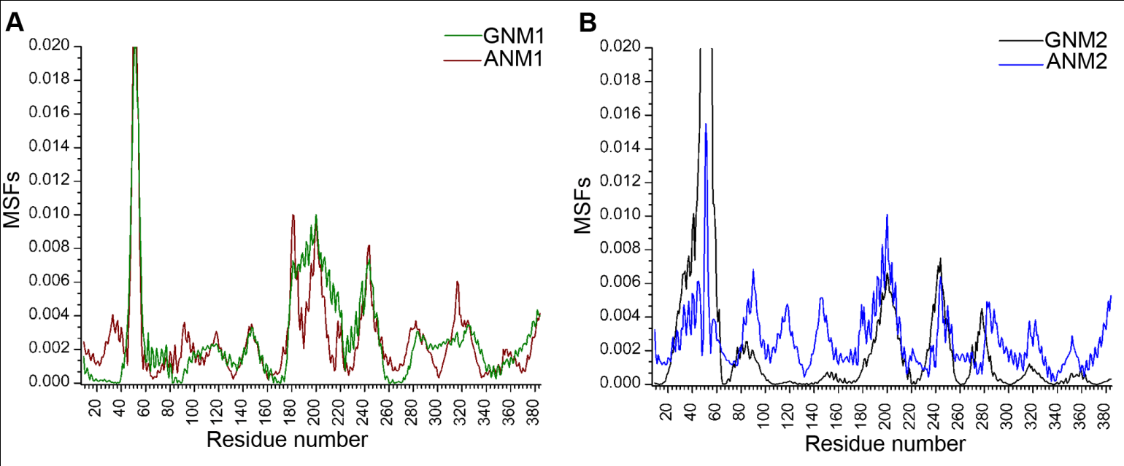

Figure S5. Correspondence between the slowest GNM and ANM modes. The two slowest GNM modes were matched to the two slowest ANM modes based on their mean-square-fluctuations (MSFs). In both panels the fluctuations are normalized, with the maximum value set to 0.02 for clarity. The matches show correspondence between the general shape of the MSFs and approximate hinge regions of GNM1 and ANM1 (A), as well as of GNM2 and ANM2 (B).

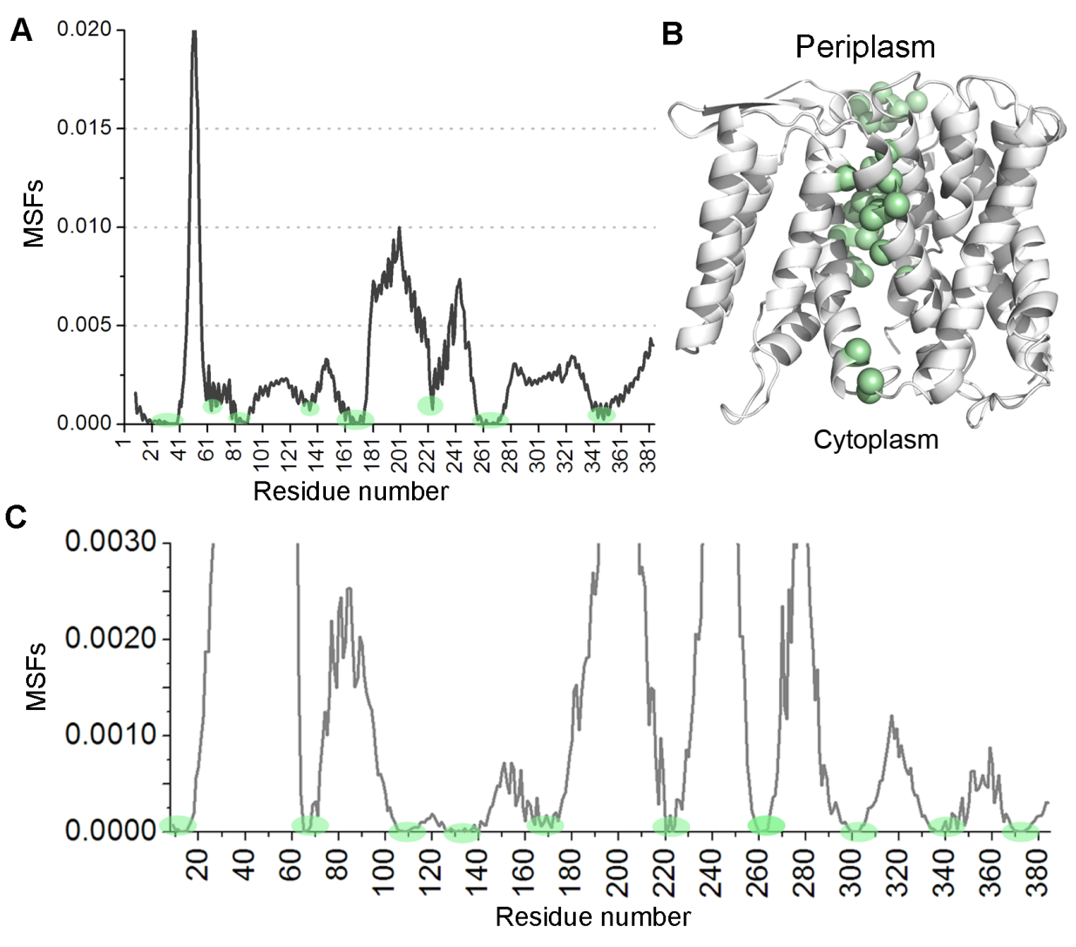
Figure S6

Figure S6. MSFs and hinges of GNM1 and GNM2. A. MSFs of the slowest GNM mode (GNM1). Hinge regions are indicated by green circles. B. Mapping of the GNM1 hinges on the crystal structure. The structure is viewed from the side, and shown in cartoon representation, with Cα-atoms of the hinge regions as spheres. C. MSFs of GNM2, with hinge regions marked by green circles.
Figure S7
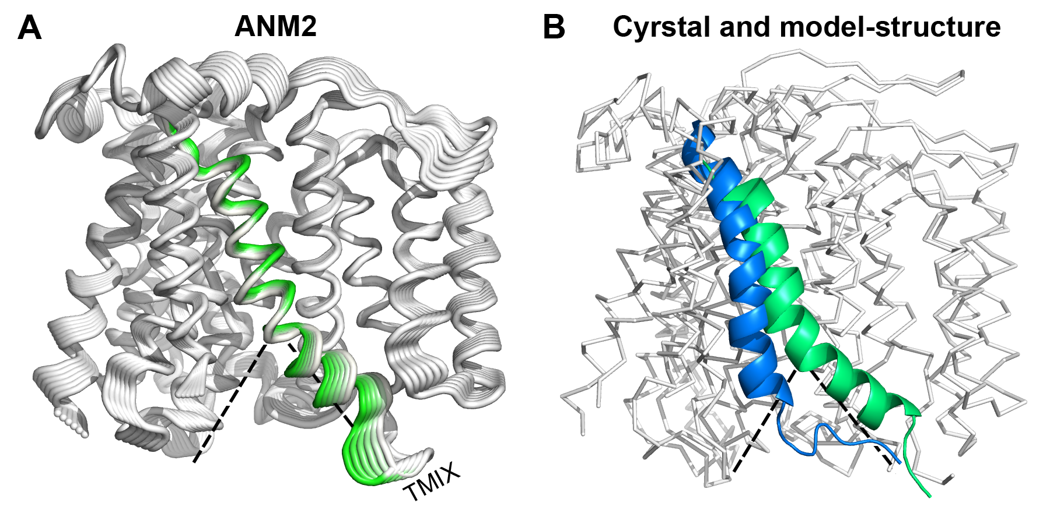
Figure S7. Similarity between the conformational changes predicted by ANM2 and by the model-structure. Dashed lines indicate the cytoplasmic funnel. A. Side view of ANM2 in cartoon representation. TM IX is colored from white to green, representing one direction of motion starting from the crystal structure (white). In this direction of motion, the cytoplasmic end of TM IX approaches the center of the funnel, with the most extreme deformation in green. B. Same side view as in panel A, displaying the crystal structure (green) and model (blue). TM IX is shown in cartoons, whereas the rest of the residues are displayed as ribbons. In both panels, the original banana-shaped conformation of TM IX straightens somewhat as it approaches the center of the cytoplasmic funnel.

Figure S8
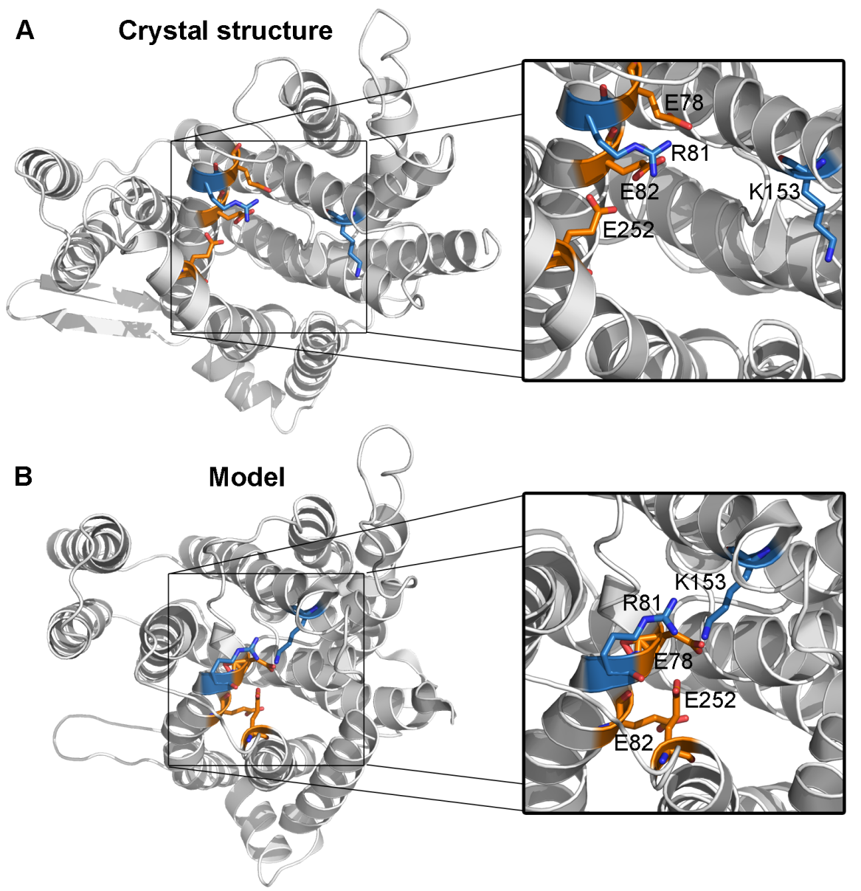
Figure S8. A conserved cluster of charged residues on the cytoplasmic side: interactions in the crystal- vs. the model-structure. In both panels, the left-hand side shows cytoplasmic views of the crystal- and model-structures in cartoon representation, colored white. The conserved titratable residues Glu79, Arg81, Glu82 (all from TM II), Lys153 (TM V) and Glu252 (TM XI) are shown as sticks; Glu in orange and Arg/Lys in blue, with oxygen and nitrogen atoms colored red and dark blue, respectively. The right-hand side shows a close-up view of the charged cluster. A. In the crystal structure, Lys153 is far from the other titratable residues. B. After the proposed structural changes in TMs II and IX, Lys153 could interact with the negatively-charged residues in the model-structure.

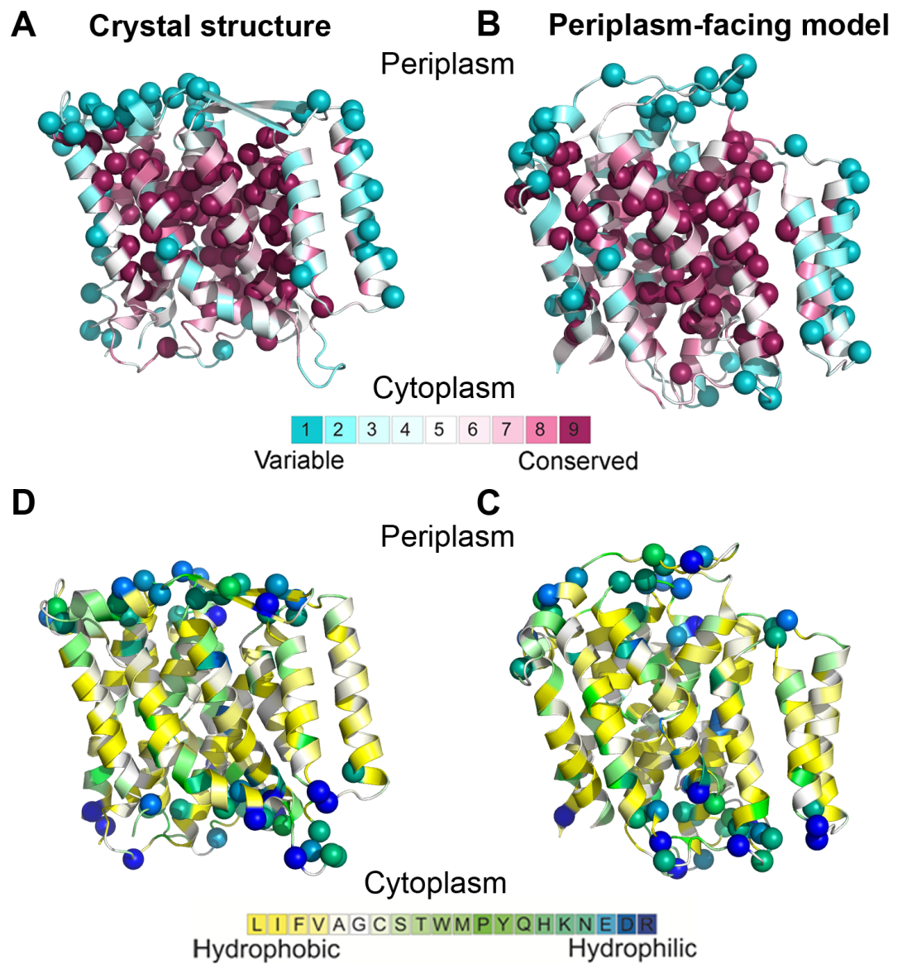
Figure S9

Figure S9. Evolutionary conservation analysis and hydrophobicity profile of the NhaA crystal structure and periplasm-facing model. In all panels the crystal structure and periplasm-facing model are viewed from the side with the cytoplasm below, and are shown in cartoon representation. A & B. Evolutionary conservation grades, as computed by the ConSurf webserver (http://consurf.tau.ac.il/, (12)), are mapped on the crystal structure and model, with cyan-to-maroon indicating variable-to-conserved according to the color bar below. The Cα atoms of the most highly conserved and variable categories, assigned grades of 9 and 1, respectively, are shown as spheres. C & D. The crystal structure and periplasm-facing model are colored by hydrophobicity according to the scale of Kessel and Ben-Tal (17), displayed below. Cα atoms of charged and highly polar amino acids, namely, Asp, Glu, Lys, Arg, His, Gln and Asn, are shown as spheres, excluding positions buried in the protein core. Reassuringly, the highly conserved and polar residues are in the core of the model-structure, while the lipid-facing regions include more variable and hydrophobic residues.

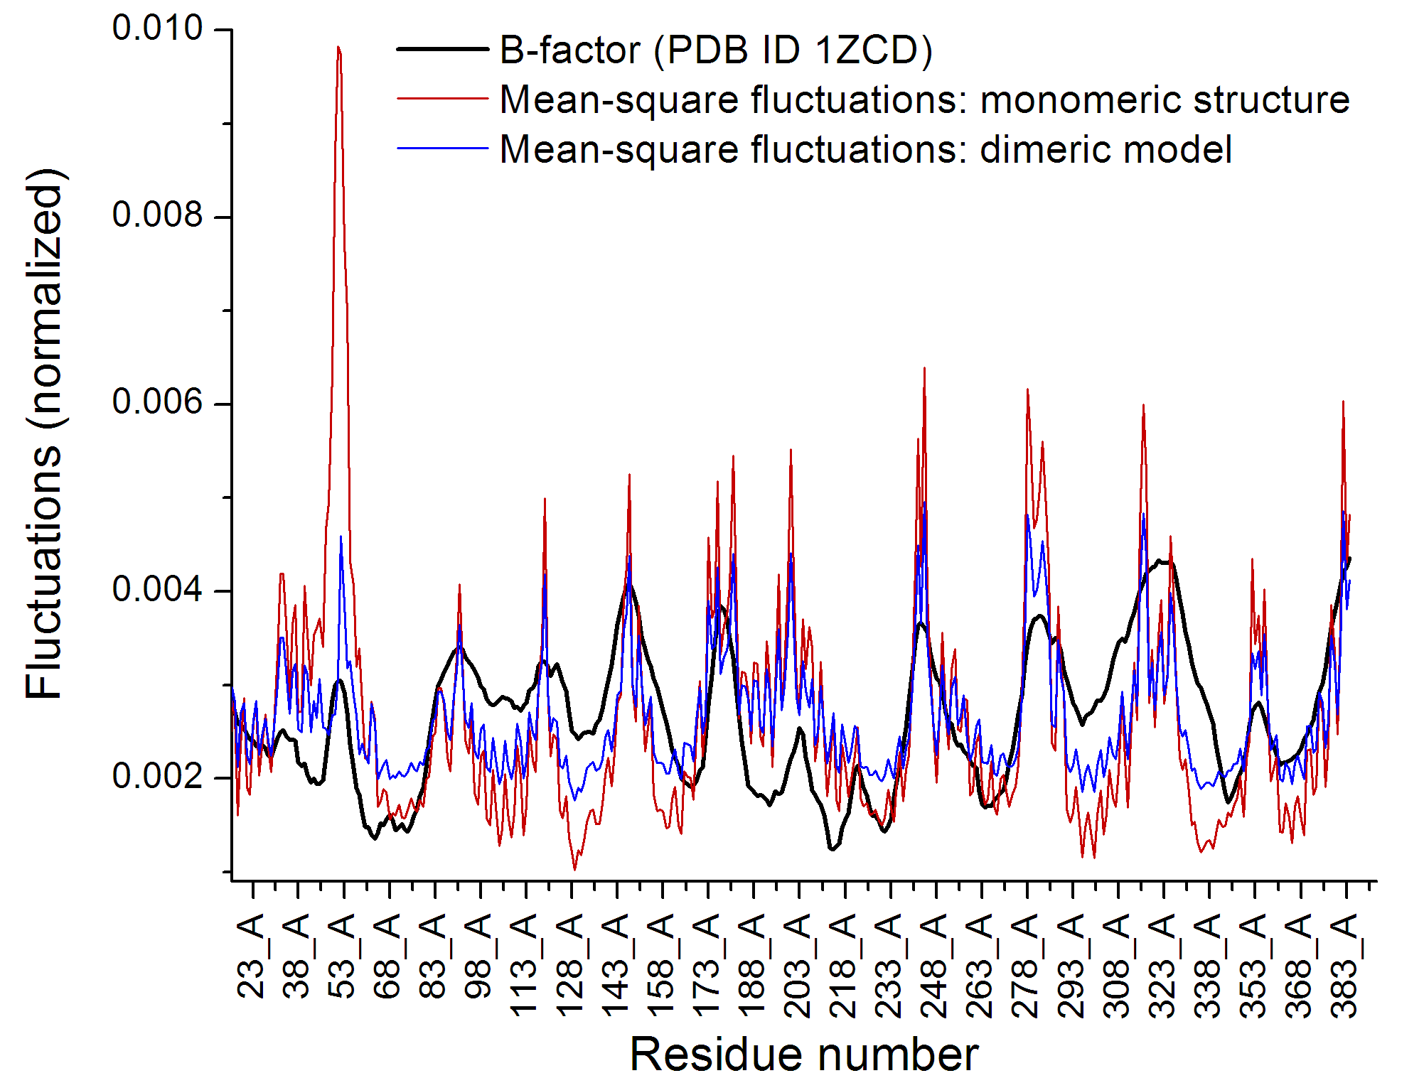
Figure S10

Figure S10. Comparison of the B-factor of the crystal structure to GNM-derived mean-square fluctuations. Mean-square fluctuations (MSFs) for all GNM modes were calculated and normalized for both the monomeric crystal structure (PDB ID 1ZCD, red) and the dimeric model (PDB ID 3FI1, blue). The experimental B-factor values of the crystal structure were also normalized, and were compared to the elastic network MSFs. It is evident that there is good agreement between the computational and experimental data with regard to the general shape of the fluctuations. The exception to this is the peak in the GNM calculations of the monomeric structure around residues 45-60. This region, corresponding to the beta hairpin between TMs I and II, is more mobile, which is anticipated since it is not restrained in the monomeric structure as it would be in the physiological (dimeric) conformation.

Table S1. Experimentally-established importance of hinge regions.
A list of the hinge regions shown in Figs. 4A and 5A. Experimental support for the importance for function or pH activity ranges of these regions, or of proximal residues, is described.
Hinge region | Position | GNM | Experimental support | Ref.
10-15 | TM I | 2 | G14R displayed no tolerance to Li⁺ | (18)
32-38 | Loop TM I-2 | 1 | Not available
64 | TM II | 1 | N64C shifted pH range; D65C increased apparent K_{m} to Na⁺ and Li⁺ and changed the pH response | (13)
65-67 | TM II | 2 | As above for hinge around position 64; L67C increased K_{m} and shifted the pH range | (13)
82-83, 86 and 89 | Loop TM II-3 | 1 | E82C affected pH activity range and K_{m} | (13)
106-111 |  |  | No salt tolerance upon mutation in G104 | (19)
126-140 | TM IV | 2 | Alkaline shift and impaired growth in G125C; mutation in A127 affected the K_{m} , the pH dependence, and also activity; D133C, T132C, and P129L affected the apparent K_{m}. | (19-22)
135 | TM IV | 1,2 | F136C impaired growth | (20)
164-165 and 168-171 | TM V | 1,2 | Mutations in D63 and D164 impaired function | (18,23,24)
220-223 | TM VIII | 2 | As above for hinge around position 224
224 | TM VIII | 1 | Mutation in H225 affected pH range, and drastic replacements impaired function | (18,25-27)
260-270 | TM IX | 1 | L262C presented a shifted pH activity range; mutation in F267 reduced H⁺/Na⁺ stoichiometry | (15)
260-263 | TM IX | 2 | As above for hinge in 260-270
299-303 | TM I0 | 2 | G299C reduced activity and increased K_{m}, K300 and G300 were sensitive to drastic mutations | (18,22)
334-341, 344-348 | TM I1 | 2 | C335R and G336L affected salt tolerance; G338S shifted pH dependency range and affected activity; S342 and F344 as above. | (15,18-20,28,29)
344, 348 | TM I1 | 1 | S342C caused acidic shift in activity range; mutations in F344 affected function or shifted pH dependence | (15,18-20)
369-375 | TM I2 | 2 | Not available

Table S2. Cα-Cα distances of the three pairs of residues tested for cross-linking (Fig. S8).
Distances in Å measured in the crystal structure, periplasm-facing model and structural conformation reflecting the most extreme ANM2-derived alteration.
Structure\Cα-Cα distance | S146-E252 | L138-H256 | A142-H256
Crystal structure | 23.7 | 13.7 | 16.3
Periplasm-facing model | 16.4 | 11.1 | 13.1
Extreme ANM2 alteration | 19.1 | 11.7 | 13.6
MOVIE LEGENDS
Movie S1. Motion according to the ANM1 mode, matched to GNM1. Cytoplasmic view of the NhaA structure, colored according to the dynamical correlation obtained from the GNM1 mode. The motions of the helices included in the bundle of the TM IV-XI assembly and flanking region are positively correlated (red), and display opposite correlation to the motions of the helices in the adjacent bundle (blue). This ANM mode depicted a rotational, clockwise motion around the putative symmetry axis situated at the center of the funnels. Note that the motion of the beta-sheet between TM1 and TM2 is probably overestimated, as the calculation was performed on the monomeric structure; in vivo, NhaA is a dimer (5-7), with the beta-sheet lining the dimeric interface, which in turn restricts its potential motion.
Movie S2. Motion according to the ANM2 mode, corresponding to GNM2 – cytoplasmic view. The NhaA structure is colored white. The rigid segments lining the cytoplasmic funnel correspond to the hinges of the GNM2 mode and are colored pink, purple and yellow for the cytoplasmic parts of TMs II- III, IV-V, VIII-IX, respectively. During the motion, the segment containing TMs II-III moves away from the putative center point of the funnel while TMs IV-V and VIII-IX approach, and vice versa.
Movie S3. Motion according to ANM2, corresponding to the GNM2 mode – side view. The protein is presented as in Movie S2, but viewed from the side with the cytoplasmic end below. This view emphasizes the closing of the cytoplasmic funnel, observed in this mode of motion.
Movie S4. The AMN2 mode compared to the crystal structure and periplasm-facing model – cytoplasmic view. The fluctuations predicted by the ANM2 mode of motion (in one direction) are shown in white cartoon representation. The crystal structure and periplasm-facing model are superimposed and shown as cylindrical helices, in green and blue, respectively. It is apparent that the motion depicted in ANM2, in which funnel-lining segments approach the funnel center, corresponds to the putative transition between the crystal structure and the model-structure.
Movie S5. The ANM1 mode in relation to the crystal structure and periplasm-facing model – cytoplasmic view. Same coloring and view as in Movie S4, but in comparison to the slowest mode of motion (ANM1). Note that as ANM1 herein and ANM2 (Movie S4) are orthogonal modes of motion, they reflect distinct movement, unrelated to one another. The rotational trend exhibited in ANM1 is also evident when examining the periplasm-facing model superimposed on the crystal structure.
Movie S6. The ANM1 mode in comparison to the crystal structure and periplasm-facing model- periplasmic view. Same as Movie S5, but viewed from the periplasmic side.

